Week 2: Circuits and breadboards

# Assignment A1:

## Step 1:

1. The maximum current the Arduino can provide via VCC - 200mA
2. The maximum current the Arduino can provide via digital output – 40mA
3. The maximum current the Arduino can drain via GND – 200mA
4. The voltage range that the Arduino sees as HIGH on digital input pins - >= 0.6Vcc to Vcc + 0.5V
5. The voltage range that the Arduino sees as LOW on digital input pins - <= 0.3Vcc to – 0.5V
6. The voltage range of the Arduino outputs as HIGH on digital output pins - >= 4.2V to Vcc + 0.5V
7. The voltage range of the Arduino outputs as LOW on digital output pins - <= 0.9V to -0.5V

## Step 2:

1. The max Forward current of the LED is 20mA
2. The max Forward voltage of the LED is 3V
3. Use Ohm’s law and Kirchhoff’s laws to calculate the series resistor R for the maximum 𝐼𝐼𝐹𝐹 and 𝑈𝑈𝐹𝐹. Show your calculations (formula’s and results) and your reasoning with meshes and nodes.

A: 150Ω

Reasoning:

* The max Forward current that the led can take is 20mA.
* Using Ohm’s law, we can calculate the resistance we need to run the LED with 5V at 20mA:

R = V/I

* Where the current (I) is 20mA (0,02A) and the voltage (V) is 3V (from the LED data sheet) => R = 3/0,02 = 150Ω

1. Recalculate the resistor for this safety limitation. You will use this “safe” resistor in the next step. Show how you calculated the values (formula’s and results).

A: 100Ω

Reasoning:

* The max Forward current that the led can take is 20mA.
* Using Ohm’s law, we can calculate the resistance we need to run the LED with 2V at 20mA:

R = V/I

* Where the current (I) is 20mA (0,02A) and the voltage (V) is 2V (from the LED data sheet) => R = 3/0,02 = 10

1. If the resistor value is not a standard resistor in the E3 series, then can you create this resistor using standard resistors in the E3 series? Explain your answer and show the calculations.

A: Fortunately, these values are standard resistor values, but it is also possible to use resistors whit different values which sum up to the value you need or a close enough value.

Ex: 100 Ω + 51 Ω = 151 Ω which is close to 150 Ω in the first calculation.

## Step 3:

1. Measure VCC (𝑈𝑈), the voltage drops over the resistor (𝑈𝑈𝑅𝑅) and the LED (𝑈𝑈𝐹𝐹), and measure the current (𝐼𝐼) in the circuit. Explain the measurements.

A:

* The voltage-drop over the resistor is ~2.5V (value over the resistor - ~2.5V)
* The Voltage-drop over the LED is ~0.5V (value over the LED - ~ 2V)
* The current in the circuit is 4.5V

1. the measured values ​​are identical to the calculated values ​​and the data in the datasheet. Before making the measurements and calculations, I used the datasheet's output (information) to calculate the value of the "safe" resistor needed to limit the current through the LED at 5V power from any Arduino pin. When calculating the value of the "safe" resistor, I determined that, at a 2V power supply, the direct current through the diode should not exceed 0.010A, and using the Ohm's law, I calculated that the "safe" resistor should have a resistance of 300 Ohms. While constructing the circuit, due to the lack of a 300 Ohm resistor, I used three series resistors, each with a resistance of 100 Ohms, as shown in the diagram.

1. Night mode:

Using a potentiometer connected in series with the LED such as in the schematic, will allow for a smoother control over the light intensity of the LED. This way we can change the intensity of the LED however we see fit.

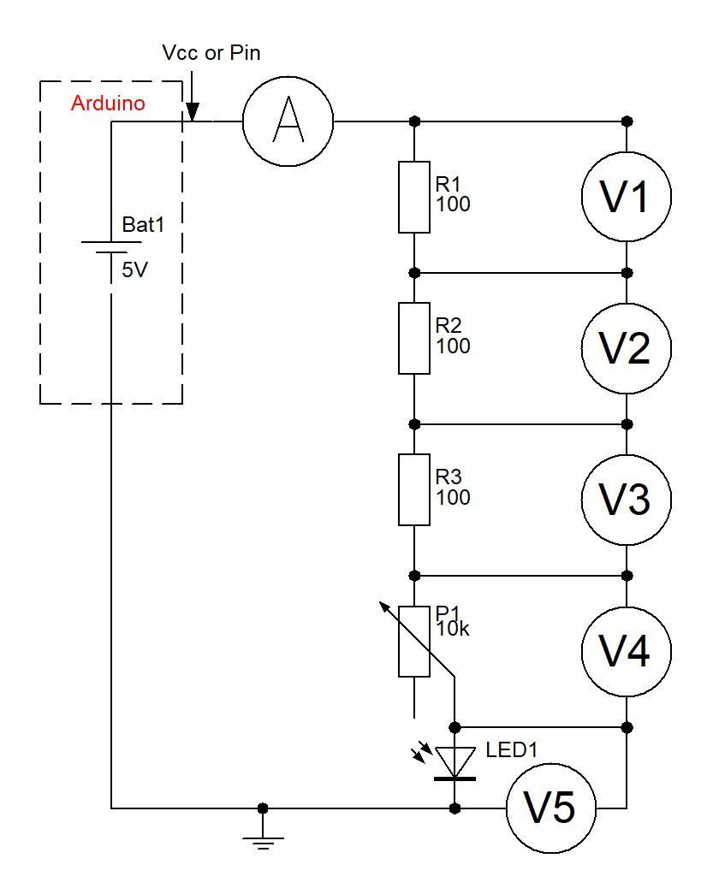

1. The forward voltage is 2V
2. The forward current is 2mA
3. Compare these measured values with the characteristics in the datasheet, and

proof that this is correct using Ohm’s law and Kirchhoff’s law. Explain your

answer and show the calculations.

**Forward voltage:** U=IR

**For each resistor**: U1=IR1, U2=IR2 U3=IR3

On the one hand Because the resistors are connected in series with the LED the current flowing through the hole circuit is the same in every point in it. On the other hand, the applied voltage is divided between all the element in the circuit and it can be described with this equation. If we take in consideration the fact that **U4 = 2V,** this means that:

*U = IR1 + IR2 + IR3 + 2 => U - 2 = I(R1+R2+ R3)  =>  I = (U – 2)/(R1+R2+R3)*

The voltage U that I use is a constant – 5V

The current flowing is the circuit should not exceed 20mA. This norm is required for normal operating of the circuit.

**Thus**: 5 - 2 = 0,01(R1+R2+R3) => R1+R2+R3 = 3/0,01 => R1+R2+R3 = 300 Ω

# Assignment 1B:

1. The Anode of an LED is usually Longer than the Cathode.
2. The wavelength of the emitted light is 630nm.
3. To limit the current going through the LED in order to protect it.
4. Forward voltage is the difference of the voltage on both ends of the LED, if the voltage on the anode is higher than that on the cathode Current will flow through the LED and this is called Forward current. On the other hand, if the voltage on the anode is lower than that on the cathode the LED usually won’t light up, this is called Reverse voltage.
5. The max Reverse voltage of an LED is 6V
6. Exceeding the max reverse voltage on LED might lead to current flowing through the LED and destroying it.
7. Intensity of light emitted by LED depended on the forward current flowing in LED, with increase in forward current, intensity of light emitted increases.

LED light output varies with the type of chip, encapsulation, efficiency of individual wafer lots and other variables. Several LED manufacturers use terms such as "super-bright," and "ultra-bright" to describe LED intensity. Such terminology is entirely subjective, as there is no industry standard for LED brightness.

Luminous intensity is roughly proportional to the amount of current supplied to the LED.

The greater the current gives the higher the intensity.

# Assignment 1C:S

1. It is not possible because when using the previous circuit with 12V power supply the Current will be more that 20mA thus destroying the LED in the process.

Proof: if we use Ohm’s law to calculate the current in the circuit, we will see that it exceeds the max forward current of the LED.

* Using 5V in the circuit

I = V / R => I = 5 / 300 = 0.016A (16mA)

* Using 12V in the circuit

I = V / R => I = 12 / 300 = 0.04A (40mA)

1. If we use the 12V power supply, we will need a resistor of bigger value.

Proof: Using the Ohm’s law we can determine what value will need.

R = V / I => R = 12 / 0.02 = 600 Ω

Using 600 Ω resistor instead of the 300 Ω will allow us to use the previous circuit at 20mA which is risky given the fact that the max Forward current of the LED is 20mA

1. The LED start to conduce current when the voltage is above ~1.8V. This happens because the Led is base on a semiconductor which requires a certain amount of voltage to be a applied in order for the semiconductor to conduct current (Become a conductor).

* Reference: <https://youtu.be/9uHZB7-T_XA> .

1. Unfortunately, I was not able to test this section of the Assignment

# Assignment 1D:

1. Done!
2. Bouncing is an event that happens when a button is pressed. In its essence bouncing is just an instability in the connection of two metal surfaces in the button. This can be troublesome because it leads to a not responsive enough button. The instability usually last for a few milliseconds and it could be easily fix with some software: <https://www.allaboutcircuits.com/technical-articles/switch-bounce-how-to-deal-with-it/>
3. The bouncing library allows us to use different functions to detect changes in the state of the button.

* Debounce.change() – returns the state of the button (uses bitwise operations)
* Debounce.update() – returns true if the pin changes stat.
* Debounce.fell() – detects falling edge changes (from HIGH to LOW)
* Debounce.rose() – detects rising edge changes (from LOW to HIGH)

The library also supports some legacy functions from the old version.

# Useful Information:

**LED Series Resistance.**

The series resistor value RS is calculated by simply using Ohm´s Law, by knowing the required forward current IF of the LED, the supply voltage VS across the combination and the expected forward voltage drop of the LED, VF at the required current level, the current limiting resistor is calculated as:

**LED Series Resistor Circuit**

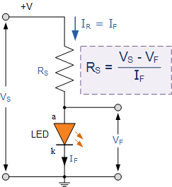

**Light Emitting Diode Example No1**

An amber coloured LED with a forward volt drop of 2 volts is to be connected to a 5.0v stabilised DC power supply. Using the circuit above calculate the value of the series resistor required to limit the forward current to less than 10mA. Also calculate the current flowing through the diode if a 100Ω series resistor is used instead of the calculated first.

1. series resistor required at 10mA.

light emitting diode series resistor

1. with a 100Ω series resistor.

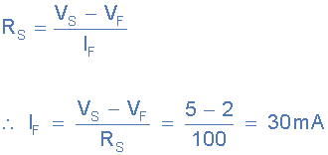

We remember from the Resistors tutorials, that resistors come in standard preferred values. Our first calculation above shows that to limit the current flowing through the LED to 10mA exactly, we would require a 300Ω resistor. In the E12 series of resistors there is no 300Ω resistor so we would need to choose the next highest value, which is 330Ω. A quick re-calculation shows the new forward current value is now 9.1mA, and this is ok.